Neck / Chin / Lower Face Liposculpture

Fullness in the neck and under the chin can be very resistant to dieting, and is surprisingly common even amongst young people. It can be hereditary and usually increases with age. It affects both men and women. Liposculpture to the chin can greatly improve the look of the face, and even though only a small amount of fat is removed the improvement in appearance can be dramatic. Many people feel as though their face looks much younger after the treatment and friends and relatives comment on their rejuvenated appearance, not even realising that any procedure has been performed.
Jowls are small areas of fatty tissue in the lower part of the face just on the other side of the chin. It is possible to reduce these areas by careful liposculpture to the face from the same small (2mm) incisions just below the jaw. The lower border of the face looks much cleaner adding to the rejuvenated look.
Even if not much fatty tissue is removed with liposculpture and the skin of the neck appears loose, liposculpture will allow the skin to contract and so take on the shape of the jaw and the muscles of the neck. The procedure is not a facelift but can provide quite dramatic results without the need for skin excision, lifting and tightening. Liposculpture essentially “de-weights” the skin and the skin naturally retracts to cover the new shape of the underlying tissue.
Liposculpting the neck has become one of the more common cosmetic surgical procedures performed in our office. Proven safety, minimal discomfort, and outstanding results have made it the most popular way to contour the neck to produce a more youthful, athletic appearance. Men and women find it particularly effective in establishing a strong jaw line, which optimises a youthful, slim, and younger-looking neck contour.
The procedure is performed in our office outpatient surgery under a local anaesthetic. Tiny incisions are made under the chin and under each ear. A thin hollow tube (cannula) is inserted into the fat layer through the small incision. When suction is applied to the tube, which is moved through the tissue in a fan shaped pattern, fat can be removed in a very controlled, uniform manner. By contouring the fat to the best thickness in each area of the neck, we are able to establish the optimal neck contour for each patient. An elastic pressure bandage is applied which minimises swelling and bruising. Patients experience some tightness in the neck but rarely have any pain. Neck contouring creates a firmer, smoother and more refined appearance to the neck and chin. Even without making any other changes to the face, improving the contour of the neck can dramatically improve one’s appearance, helping a patient look years younger or look like he or she has lost weight. Neck contouring can also help restore balance to facial features by providing a better defined jawline that frames the rest of the face.

The procedure is an extension of liposculpture performed on other areas of the body and should be read in conjunction with the general consent form for liposculpture. Neck/ chin liposculpture has been performed under local anaesthesia since the 1980’s very successfully and very safely. Swelling and bruising can occur after any liposculpture procedure but the swelling in the neck tends to drain quite quickly after the procedure because the neck is located above the level of the heart. In that respect, swelling does not have to fight gravity to be removed from the body. Bruising tends to occur more readily over the jowls but within a week has virtually disappeared. Some people don’t bruise at all.
In less than 1% of patients, there could be temporary damage to one of the smiling muscles nerves (marginal mandibular branch of the facial nerve). Cannulas are blunt but move under the skin and could potentially cause some minor damage to the nerve, because the nerve cannot be seen. It may take 6-8 weeks for the nerve to regain its function. The nerve is not at risk of being severed as the cannulas are blunt and will, with time, regain its function. Sometimes, heat generated by the back and forth movement of the cannula may cause this temporary inflammation of the nerve. The area at risk of damage is marked out prior to the procedure, in order to help prevent this temporary complication.
A compression garment (pictured) is worn for 2 days and 2 nights and only taken off to have a shower. Thereafter, it can be a good idea to wear the garment in the evenings when you get home for another 2-3 days. Results are evident immediately after the procedure but it can often take up to 6 months for the skin to settle down after neck liposculpture. It can feel tight and lumpy under the chin. Massaging afterwards is helpful and instructions on how to do this will be given.
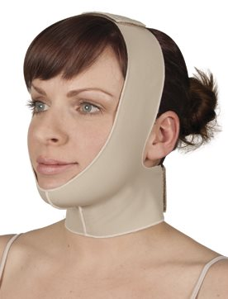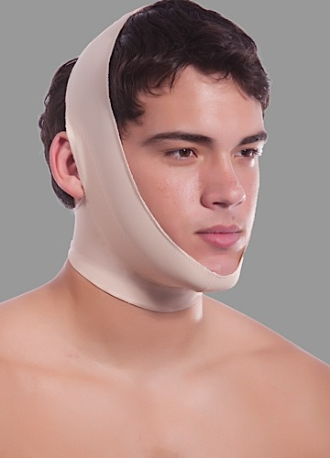

I agree to follow the instructions given to me by my doctor, to the best of my ability, before, during and after my procedure, and to notify her of any problems that occur.

I hereby acknowledge that I have read this information on liposculpture and neck/ chin liposculpture and have discussed with and asked questions of my doctor, who has answered them to my understanding and satisfaction.

I agree to undergo liposuction of the neck/ chin liposculpture Yes/No

Patient’s name PRINTED in full ………………………………………………………………………

Patient’s Signature …………………………………. Date ………………………………………...

Doctors name PRINTED in full ………………………………………………………………………

Doctor’s signature ………………………………….. Date ………………………………………..

